OOP & JavaFX Shapes

LEGAL NAME LEONARD-ADRIAN BUNEA
PREFERRED NAME ZOE MCFIFE
TIME SPENT 05:44:33

Table of Contents
Table of Contents 1
Table of Figures 2
Shapes 3
Vector2 3
Shape 4
Polygon 5
Point 6
Circle 6
Rectangle 7
Line 7
Triangle 8
Ellipse 9
Star 9
JUnit Tests 10
Drawing Shapes 11
Drawer Class 13
Creative Scene 16

Table of Figures
Figure 1: Vector2 4
Figure 2: Shape Interface 5
Figure 3: Polygon Class 6
Figure 4: Circle Stuff 7
Figure 5: Rectangle Stuff 7
Figure 6: Line Stuff 8
Figure 7: Triangle Constructor 8
Figure 8: Triangle Stuff 8
Figure 9: Ellipse stuff 9
Figure 10: Star Stuff 10
Figure 11: JUnit Tests 10
Figure 12: ShapeApplication 11
Figure 13: Drawable Interface 11
Figure 14: Circle Draw 12
Figure 15: Drawing! 12
Figure 16: Drawer 14
Figure 17: drawShapes but better 15
Figure 18: Picture 15
Figure 19: Creative Scene 16

Shapes

Vector2
To represent positions, I created the Vector2 class that represents, well, a 2D vector. It has a bunch of helper methods to calculate distances between vectors amongst other things. Most of them aren’t really needed anyways.
public class Vector2
{
public double x;
public double y;
public static final Vector2 ZERO = new Vector2(0, 0);
public Vector2(double x, double y)
{
this.x = x;
this.y = y;
}
public Vector2 add(Vector2 other)
{
return new Vector2(this.x + other.x, this.y + other.y);
}
public Vector2 subtract(Vector2 other)
{
return new Vector2(this.x - other.x, this.y - other.y);
}
public Vector2 scale(double scalar)
{
return new Vector2(this.x * scalar, this.y * scalar);
}
public double dot(Vector2 other)
{
return this.x * other.x + this.y * other.y;
}
public double magnitude()
{
return Math.sqrt(this.x * this.x + this.y * this.y);
}
public Vector2 normalize()
{
double mag = magnitude();
if (mag == 0) return new Vector2(0, 0);
return new Vector2(this.x / mag, this.y / mag);
}
public double distanceTo(Vector2 other)
{
return this.subtract(other).magnitude();
}
@Override
public boolean equals(Object other)
{
if (this == other) return true;
if (other == null || getClass() != other.getClass()) return false;
Vector2 vector2 = (Vector2) other;
return Double.compare(vector2.x, x) == 0 && Double.compare(vector2.y, y) == 0;
}
@Override
public String toString()
{
return String.format("Vector2(%.2f, %.2f)", x, y);
}
}
Figure 1: Vector2
I called it Vector2 because I’m used to Godot naming conventions.

Shape
The Shape interface has the area() and perimeter() methods.

public interface Shape
{
double area();
double perimeter();
}
Figure 2: Shape Interface

Polygon
The Polygon class is the base abstract class for all shapes. Each Polygon has a position. Each subclass implements equals() and toString(). For equals() I didn’t compare the Polygon positions, because I feel like when comparing, say a Circle, it doesn’t matter where the Circle is, if both Circles have the same radius, they’re the same. It doesn’t really matter this much for this exercise.
public abstract class Polygon implements Shape
{
private Vector2 position;
Polygon()
{
setPosition(Vector2.ZERO);
}
Polygon(Vector2 position)
{
setPosition(position);
}
public Vector2 getPosition()
{
return position;
}
public void setPosition(Vector2 position)
{
this.position = position;
}
@Override
public String toString()
{
return String.format("%s at %s", getClass().getSimpleName(), getPosition());
}
@Override
public boolean equals(Object obj)
{
if (this == obj) return true;
if (obj == null || getClass() != obj.getClass()) return false;
Polygon other = (Polygon) obj;
return getPosition().equals(other.getPosition());
}
}
Figure 3: Polygon Class

Point
The point is nothing fancy. I didn’t reimplement the distanceTo() method here, because the Vector2 class already implements it.

Circle
Circle is also pretty simple.
@Override
public double area()
{
return Math.PI * radius * radius;
}
@Override
public double perimeter()
{
return 2 * Math.PI * radius;
}

public Circle scale(double scale)
{
return new Circle(getRadius() * scale);
}
public boolean isBiggerThan(Circle other)
{
return this.radius > other.radius;
}
Figure 4: Circle Stuff

Rectangle
The rectangle is also simple to implement. Nothing fancy.
public double getDiagonalLength()
{
return Math.sqrt(getWidth() * getWidth() + getHeight() * getHeight());
}
@Override
public double area()
{
return getWidth() * getHeight();
}
@Override
public double perimeter()
{
return 2 * (getWidth() + getHeight());
}
Figure 5: Rectangle Stuff

Line
The line accepts a to and from parameter and calculates the midpoint automatically in the constructor when to or from gets changed. The position is set to the midpoint.
public Vector2 getMidPoint()
{
return new Vector2((from.x + to.x) / 2, (from.y + to.y) / 2);
}
public double getLength()
{
return Math.sqrt(Math.pow(to.x - from.x, 2) + Math.pow(to.y - from.y, 2));
}
Figure 6: Line Stuff

Triangle
The triangle accepts two sides and an angle in the constructor. It automatically uses ✨math✨ to calculate the missing side.
Triangle(double a, double b, double angleC)
{
super();
setA(a);
setB(b);
setAngleC(angleC);
setC(Math.sqrt(a * a + b * b - 2 * a * b * Math.cos(Math.toRadians(getAngleC()))));
}
Figure 7: Triangle Constructor
@Override
public double area()
{
double s = perimeter() / 2;
return Math.sqrt(s * (s - a) * (s - b) * (s - c));
}
@Override
public double perimeter()
{
return a + b + c;
}
Figure 8: Triangle Stuff

Ellipse
The ellipse isn’t that complicated either.
@Override
public double area()
{
return Math.PI * semiMajorAxis * semiMinorAxis;
}
@Override
public double perimeter()
{
return Math.PI * (3 * (semiMajorAxis + semiMinorAxis) - Math.sqrt((3 * semiMajorAxis + semiMinorAxis) * (semiMajorAxis + 3 * semiMinorAxis)));
}
Figure 9: Ellipse stuff

Star
The star was a bit more complicated, because I manually calculated how the perimeter formula and I’m a bit rusty with my math. I after just used the formula provided, because I didn’t want to double check my own math.
public double area()
{
return getNumPoints() * getInnerRadius() * getOuterRadius() * Math.sin(Math.PI / getNumPoints());
}
@Override
public double perimeter()
{
return 2 * getNumPoints() * getEdgeLength();
}
private double getEdgeLength()
{
return Math.sqrt(getOuterRadius() * getOuterRadius() + getInnerRadius() * getInnerRadius() - 2 * getOuterRadius() * getInnerRadius() * Math.cos(Math.PI / getNumPoints()));
}
Figure 10: Star Stuff

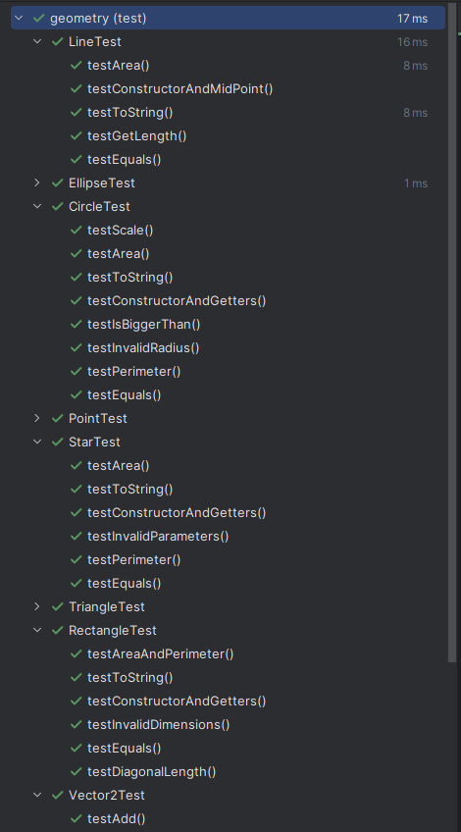
JUnit Tests
Figure 11: JUnit Tests

I didn’t clamp negative values, I instead threw an invalid argument error because I feel like it doesn’t make sense to not throw an error there.

Drawing Shapes
First, I migrated my previous project to a new JavaFX project and removed the FXML stuff because I don’t need to mess around with that just yet.
public class ShapeApplication extends Application
{
@Override
public void start(Stage stage) throws IOException
{
stage.setTitle("Drawing Operations Test");
Group root = new Group();
Canvas canvas = new Canvas(800, 600);
GraphicsContext gc = canvas.getGraphicsContext2D();
drawShapes(gc);
root.getChildren().add(canvas);
stage.setScene(new Scene(root));
stage.show();
}
Figure 12: ShapeApplication

I added another interface for the Polygon class.
public interface Drawable
{
void draw(GraphicsContext gc, Color color);
}
Figure 13: Drawable Interface

Each shape implements its own draw method.
@Override
public void draw(GraphicsContext gc, Color color)
{
gc.setFill(color);
gc.fillOval(getPosition().x - radius, getPosition().y - radius, radius * 2, radius * 2);
}
Figure 14: Circle Draw
private void drawShapes(GraphicsContext gc)
{
Point point = new Point(new Vector2(100, 100));
point.draw(gc, javafx.scene.paint.Color.RED);
Circle circle = new Circle(new Vector2(400, 300), 150);
circle.draw(gc, javafx.scene.paint.Color.GREEN);
Ellipse ellipse = new Ellipse(new Vector2(600, 200), 100, 50);
ellipse.draw(gc, javafx.scene.paint.Color.BLUE);
Line line = new Line(new Vector2(200, 500), new Vector2(700, 200));
line.draw(gc, javafx.scene.paint.Color.ORANGE);
Rectangle rectangle = new Rectangle(new Vector2(300, 400), 200, 100);
rectangle.draw(gc, javafx.scene.paint.Color.PURPLE);
Star star = new Star(new Vector2(500, 100), 25, 50, 5);
star.draw(gc, javafx.scene.paint.Color.YELLOW);
Triangle triangle = new Triangle(new Vector2(160, 500), 60, 90, 50);
triangle.draw(gc, javafx.scene.paint.Color.CYAN);
}
Figure 15: Drawing!

Drawer Class
public class Drawer
{
private final List<Polygon> polygons;
private final GraphicsContext gc;
public Drawer(GraphicsContext gc)
{
polygons = new ArrayList<>();
this.gc = gc;
}
public Drawer(GraphicsContext gc, List<Polygon> polygons)
{
this.polygons = polygons;
this.gc = gc;
}
public void drawAll()
{
polygons.forEach(polygon -> polygon.draw(gc, getRandomColor()));
}
public void draw(int index)
{
draw(index, getRandomColor());
}
public void addPolygon(Polygon polygon)
{
polygons.add(polygon);
}
public void draw(int index, Color color)
{
if (index < 0 || index >= polygons.size())
{
throw new IndexOutOfBoundsException("Index must be between 0 and " + (polygons.size() - 1));
}
polygons.get(index).draw(gc, color);
}
private Color getRandomColor()
{
return Color.color(Math.random(), Math.random(), Math.random());
}
public List<Polygon> getPolygons()
{
return polygons;
}
}
Figure 16: Drawer

private void drawShapes(GraphicsContext gc)
{
Point point = new Point(new Vector2(100, 100));
Circle circle = new Circle(new Vector2(400, 300), 150);
Ellipse ellipse = new Ellipse(new Vector2(600, 200), 100, 50);
Line line = new Line(new Vector2(200, 500), new Vector2(700, 200));
Rectangle rectangle = new Rectangle(new Vector2(300, 400), 200, 100);
Star star = new Star(new Vector2(500, 100), 25, 50, 5);
Triangle triangle = new Triangle(new Vector2(160, 500), 60, 90, 50);
Drawer drawer = new Drawer(gc);
drawer.addPolygon(point);
drawer.addPolygon(circle);
drawer.addPolygon(ellipse);
drawer.addPolygon(line);
drawer.addPolygon(rectangle);
drawer.addPolygon(star);
drawer.addPolygon(triangle);
drawer.drawAll();
}
Figure 17: drawShapes but better

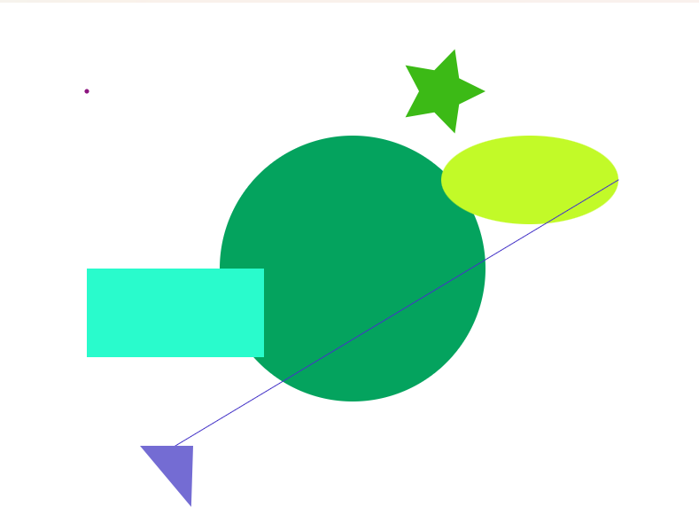
Figure 18: Picture

Creative Scene
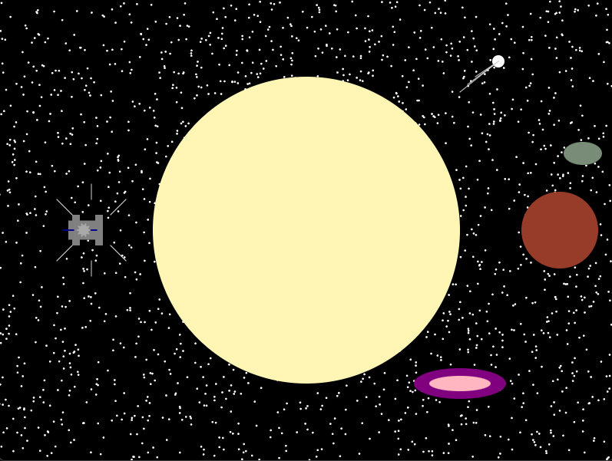
Figure 19: Creative Scene
I decided to make some random space scenery. Background is big black rectangle and the stars are randomly generated points. Star is a circle, planet is a circle, but it has a moon that is egg shaped. Left of the star I made a sorta space station that just a bunch of rectangles and there’s a star in the middle. Also a bunch of lines around because why not! There’s also a comet and a galaxy? here too.

